**Regional Electricity Trade with the Democratic Republic of Congo:**

***Preliminary Cost and Demand Analysis***

**University of Cape Town – Energy Systems Research Group, Department of Chemical Engineering**

**Authors: Bruno Merven & Gregory Ireland**

# Introduction

Strong regional electricity system interconnections allow for more economical energy resources available in different countries to be developed and shared or traded in a way that benefits all parties, as well as general surpluses or shortfalls of energy in different countries to be balanced in an open electricity trading market. For example, good hydro resources in the DRC, that if developed at scale, could bring low electricity prices but would produce more than the DRC can use for itself in the short term, opening the opportunity for multiple countries to invest together and share the benefits. Otherwise, good solar resources available in Zambia that could supply Zambia and excess sent to some of their neighbours during the day, while wind or hydro could be sent in the opposite direction at night. These objectives are currently being achieved in Africa in some places, but only to a limited extent in the several isolated African Power Pools on the continent. With significant demand and supply growth expected in the continent into the future this requires specific trade opportunities to be investigated and evaluated in more detail to justify investments with evidence.

The preliminary analysis done here investigates regional electricity trade opportunities in the year 2030 for the DRC and its neighbouring countries. The analysis combines data from the multi-region OSeMOSYS model developed in this project (UCT, 2022; RM & UCT, 2020) and the May 2022 version of the IRENA Continental Master Plan (CMP) model (IRENA, 2021 and 2022; AUDA-NEPAD, 2021). This is done using “screening supply curves” - comparing the potential supply options, their costs and energy potential, and the demand expected in the different regions to see which options are likely to meet individual national demands and which might hold the most potential for trade. The modelling here does not construct full least-cost supply models for countries outside of the DRC and does not look at the exact times of demand or generation with full timeseries, but rather looks at the bigger picture of total energy availabilities combined with investigation of day/night differences with respect to the significant solar resources available in the regions. A key assumption is that by 2030 the Southern+Western DRC grids will not yet be interconnected with the Eastern grid of the DRC (Figures shown below). Trade options and regional demands were therefore investigated separately for the two grid regions with their respective neighbouring countries.

# Methodology and Assumptions

## Overview

Screening supply curves for 2030 are constructed by progressively stacking to the right along the x-axis the current or potential annual energy production from each power plant option which is either existing, committed, or candidate for the country or group of countries under consideration. The stacked energy rectangles are sized upward along the y-axis according the Levelized Cost of Energy (LCOE) that each of the power plant options is expected to produce. The LCOE is the cost that each unit of electricity would need to be sold at to cover all potential costs e.g. capital costs, interest on loans, insurance, installation and logistical costs, fuel, repairs and breakdowns, maintenance, and salaries, etc.) over the life of the project. The specific equations used to calculate the LCOE are shown in the appendix.

The power plants are ranked from lowest LCOE on the far left to the highest LCOE on the far right. Together these add up to create the so-called “cost of supply curve”. As the best/cheapest resources are used, the cost of additional supply (or the “marginal cost of supply”) becomes more expensive moving to the right to meet increasing demand.

The total demands of the regions or countries in question are added to the charts as vertical lines to show where along the cost of supply curve the demand is. The supply options to the left of the demand lines are those that add up to meet the demand most cost effectively. Furthermore, by plotting either the combined demand of an interconnected region, or the demands of the specific countries, it is possible to see which options in combination from those countries could most economically meet the demand of the region, or allow us to see which resources are most likely to only be enough to meet a country’s own local demand.

**Western Grid**

**Southern Grid**

**Eastern Grid**

**Transmission Lines:**

HV-DC Lines

HV-AC Lines

Figure 1: Map of the three major grid networks of the DRC and neighbouring countries. Grid lines are shown in addition to a 50km buffer distance with coloured outlines showing the general coverage of the grids. The Western and Southern grids are interconnected to each other while the Eastern grid is isolated from the rest of the DRC. Other smaller local grids are not shown such as those in many of the labelled provincial capitals. Sources: Open Street Maps, Mapbox, and authors’ own GIS analysis.

The combined “Southern+Western grid”, and the” Eastern grid” of the DRC are analysed here separately as shown in Figure 1. It is assumed that until 2030, the interconnection of the Eastern DRC grid to the Southern and Western grid is unlikely (with more than 800km at the shortest distance, and over rugged terrain). Thus, to meet growing demand and to electrify the population on or near the Eastern grid it assumed to be more likely that the local domestic energy resources are developed (solar and small hydro), or joint venture projects with DRC’s neighbours (Ruzizi 3+ or others), otherwise imports from other larger projects in Rwanda, Burundi, or Uganda are considered more likely to take place in the medium term than complete internal interconnection of the DRC’s major grids.

The Western grid goes from Inga down to Boma and Matadi, and up to Kinshasa and Bandundu, and is connected to the Republic of Congo at Brazzaville, with and the potential and plans to connect to Angola. The Western grid is interconnected down to the Southern mining region via HVDC lines ending in Kolwezi, which then connects onwards to Likasi and Lubumbashi, and finally goes on to connect to Zambia. Both grids have a few additional towns or cities connected to the grid but in general they both have limited coverage. Importantly, the HVDC line that connects Kinshasa to Kolwezi over roughly 1400km does not in fact connect any of the cities or towns that it passes through or nearby, with any electricity available there coming from local mini-networks or an alternatively routed grid.

Some power plants are listed in the analysis with the same name more than once. This is because several projects (for example the Ruzizi projects) are shared by design between several countries with each getting at least a fixed portion of the energy. Additionally, several projects modelled here are refurbishment or expansion projects of existing plants (thus often keeping the same name). The associated costs, energy available for each part of the projects, and shares negotiated to be available for each country are accounted for individually and appropriately.

Inga 3 in this analysis accounts for only the energy negotiated to be available for the DRC domestically and for its own discretion to export to neighbouring countries, but excludes the share of that energy which is intended for export to South Africa as part of the Grand Inga Treaty (2013) between the RSA and the DRC. Other potential exports to South Africa beyond that portion of Inga 3 are not considered in this analysis, neither are imports to the DRC from South Africa, either directly or through joint neighbouring countries in the Southern African Power Pool (SAPP).

## Other Assumptions

For set of results presented in this report, the following assumptions are made:

* Cost, lifetime, and availability assumptions for the DRC plant options are the same as used in the 3 region OSeMOSYS model. (UCT, 2022; RM & UCT, 2020)
* Cost, lifetime, and availability assumptions for countries outside the DRC are as per IRENA CMP model May 2022. (IRENA, 2022)
* The discount rate assumed is 10% real and the monetary unit is 2019 USD.
* The year analysed and options available are for the year 2030 - for both demand and supply.
* The analysis excludes plants in the Grand Inga Project beyond Inga 3.
* In 2030 it is assumed that the Southwestern and Southern parts of the DRC are interconnected, but the Eastern part of the DRC is still isolated from the rest of the country resulting in the following regions:
  + - DRC-South+West trading with: Congo, Angola, and Zambia
    - DRC-East trading with: Rwanda, Uganda, and Burundi
* Transmission systems required to enable additional trade between countries are not analysed in detail and are assumed to be constructed, upgraded, or refurbished in parallel to the generation projects. For the relatively short distances between the countries/regions analysed here the total cost of transmission is expected to be roughly 5% of the total cost of energy.
* Plants in places may be labelled interchangeably by their number/generation either as I or 1, II or 2, III or 3, and so forth. This is unintentional and a product of the multiple project databases combined to create the final combined set. Double counting has been avoided.
* The environmental, social, or geopolitical impacts of the projects listed here were not all specifically investigated.
* The exact likelihood of construction, timing of completion, or final energy cost of each proposed/planned/candidate plant is unknown and may differ from the assumptions here.
* Lists of definitions and technology/project codes used in this report are included in the appendix.

# Results

## The DRC Southern and Western Grids and Regional Neighbours

Starting with the combined Southern and Western grids and their neighbours we can see the supply screening curve below in Figure 2, laying out the different supply options and the combined demand as described in the methodology above. Several key projects are labelled in the chart but not all can be labelled at once. The colour coding legend of the different country and power plant type is only included in the first full chart of each region but is the same legend for the related figures following on.

The full table of projects, their modelled costs, and total energy available are ranked in order of cost and given in the appendix - listed separately for the South+West and Eastern grids and neighbours.

The vertical line in black in Figure 2 shows the total combined demand in GWh for the region (~88.3 TWh). It shows that the Inga 1,2 and 3 and other DRC hydro options such as Zongo, Zongo 2, Nzilo, Nseke, Mwadingusha, Pikoa, and Matadi are in the lowest part of the curve, followed by hydro options in Angola, followed by solar in Zambia, solar in Angola, wind in Zambia, solar in DRC South+West, wind in DRC South+West, solar in Congo, then Zambian hydro, coal, diesel, and gas options – in that order.

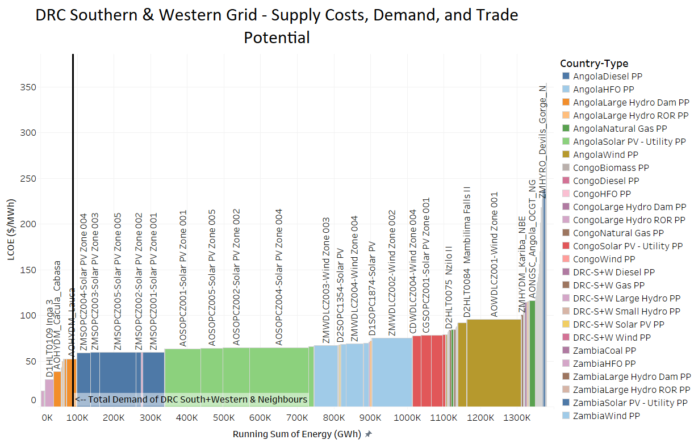

Figure 2 Supply Screening Curve for DRC South+West and Neighbouring Countries (Angola, Congo and Zambia). The black vertical line represents the total expected 2030 demand of the region made up of the DRC South+Western grids together with the immediate neighbours.

By grouping the information by country, and including separate vertical lines to represent the demand of each country we can get a better understanding of which projects are already being used to supply the demand of country they are in, or which projects if developed would first supply demand locally before exporting. Figure 3 shows the same information as Figure 2, but grouped separately by country, and with the vertical lines showing the demand of each country separately.

From Figure 3 we see that if Inga 3 is included in the DRC South+West system, the local demand in the local S+W system could be met with some spare capacity available for exports. The price level would fall below the price level of the cheapest options in the neighbouring countries.

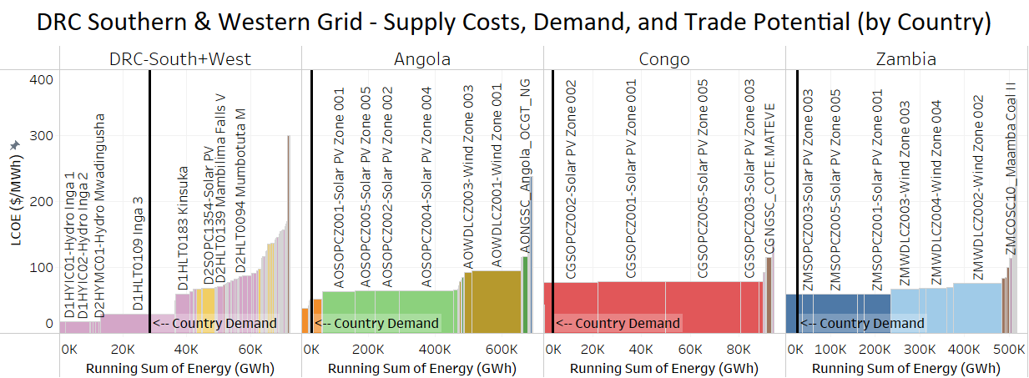

Figure 3 Supply Curve by Country (DRC S+W+Neighbours). Each black horizonal line represents the demand of that specific country. *Note that the axes and scales are not the same for each chart.*

However, should Inga 3 not be considered (see Figure 4 below), either because it does not come online by 2030 or if it’s expected final cost of energy becomes much higher, then we find solar and other hydro projects from neighbouring countries becoming economically attractive to import into the DRC (to the left of the vertical line).

The DRC South+West options to the right of the demand curve are no longer competitive in the region limiting the scope for exports from the DRC. Some of the hydro options from Angola could potentially become viable as imports into the DRC should those projects materialise and not already be allocated elsewhere in the region and sufficient transmission capacity is developed to link the countries.

However, the DRC developing specific joint large hydropower projects and transmission systems to import hydro from Angola while the DRC has been championing exporting power from the Grand Inga Project for decades seems politically unattractive. This would more likely be framed as importing potential solar power or oil/gas power from Angola while unlocking power corridors and the eventual export of Inga-based hydro power to the rest of the region.

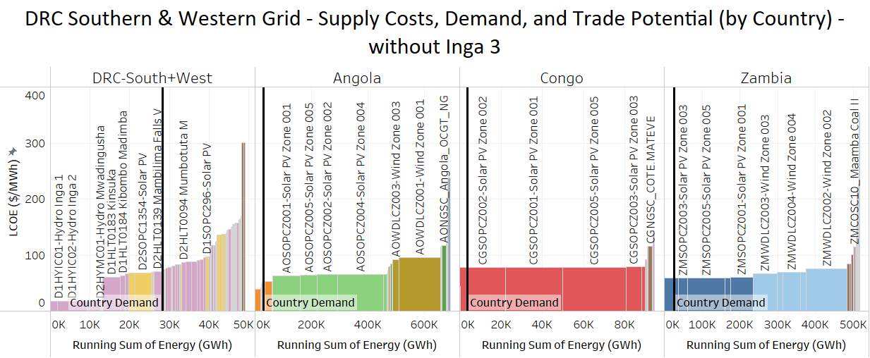

Figure 4 Supply Curve by Country (DRC S+W+Neighbours), but without Inga 3 considered possible or economic in the time frame. Each black horizonal line represents the demand of that specific country. *Note that the axes and scales are not the same for each chart.*

## The DRC Eastern Grid Region and Regional Neighbours

Next, we look at the DRC Eastern grid region and its neighbouring countries. Figure 5 below shows the supply screening curve of the region with the full table given in the appendix. The colour coding legend of the different country and power plant type is only included in the first full chart of each region but is the same legend for the related figures following on.

The vertical line in black shows the total demand in GWh for the group of countries in question (~19.6 TWh) which is significantly lower than the S+W interconnected region investigated above. The screening curve shows that Ruzizi 1,2 and 3 are in the lowest part of the curve, followed by hydro in Uganda, then Ruzizi 4 as a joint project of the region, then followed by Solar in Uganda, then Solar in Burundi and Rwanda, and Solar in DRC East. Thereafter, new candidate hydro options in Uganda, wind in Uganda, followed lastly by different gas, coal, oil, and diesel options.

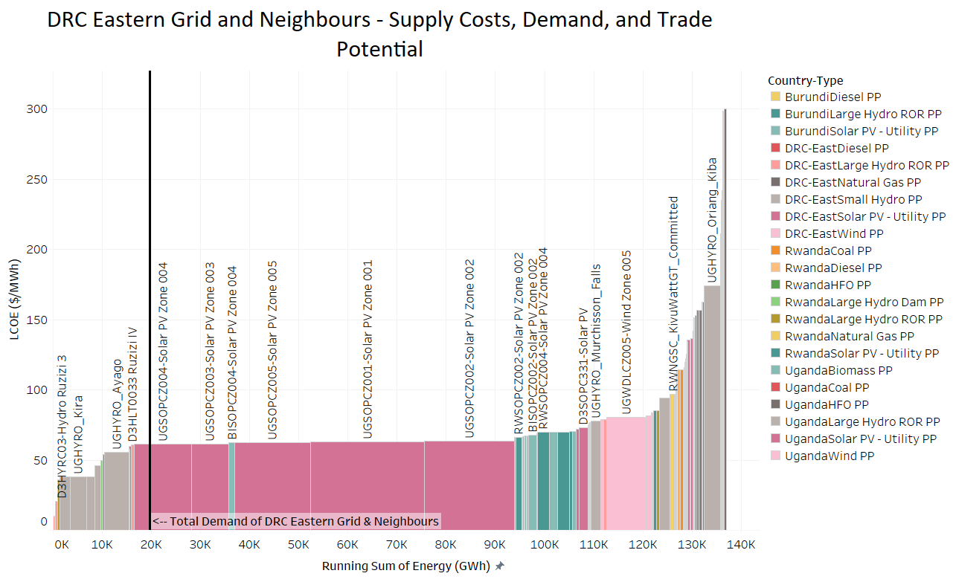

Figure 5 Supply Screening Curve for DRC East and Neighbouring Countries (Burundi, Uganda and Rwanda). The black vertical line represents the total expected 2030 demand of the region made up of the DRC Eastern grid together with the immediate neighbours.

In Figure 6 we have the same previous data but with power plant options regrouped by country. Here we see that the solar options in the East could supply a large portion of daytime electricity demand in each country. In terms of trade, we see that the cheaper hydro options in Uganda are just enough to supply Uganda without much scope for exports to DRC, leaving the larger currently undeveloped projects remaining for consideration.

The expected costs for solar in the countries in this region are mostly quite close to each other so these resources would be more likely to be developed for consumption within each country than exporting bulk energy (which alternatively, might make sense for Zambia in the South for example). The Wind resource in this area is not particularly good but are still cheaper than most of the Oil, Coal, and Gas options, but the difficulty of transporting large wind turbines through several countries and challenging terrain from the seaports of neighbouring countries might make wind power in the region not worthwhile in the medium term. Again, like in the South+West region the DRC importing specific hydro power from its neighbours may be politically unattractive so it may be unlikely for the DRC itself to make joint investments in large projects in other countries beyond its shared rivers.

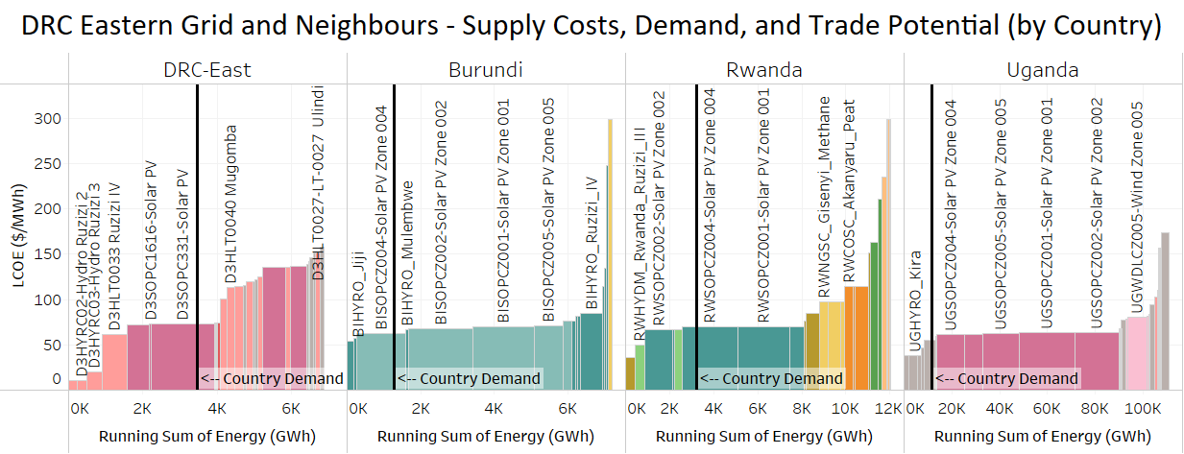

Figure 6 Supply Curve by Country (DRC East+Neighbours). Each black horizonal line represents the demand of that specific country. *Note that the axes and scales are not the same for each chart.*

Figure 7 below shows the same chart as above but with Solar PV taken out to represent potential night-time supply options. For night-time supply, we see that there would potentially be scope for the DRC to import from Uganda more cheaply than supplying it with its own options. This is contingent on the hydro options being represented adequately and the planned transmission lines being built on time, with sufficient capacity, and the overarching political will required to go forward with the projects.

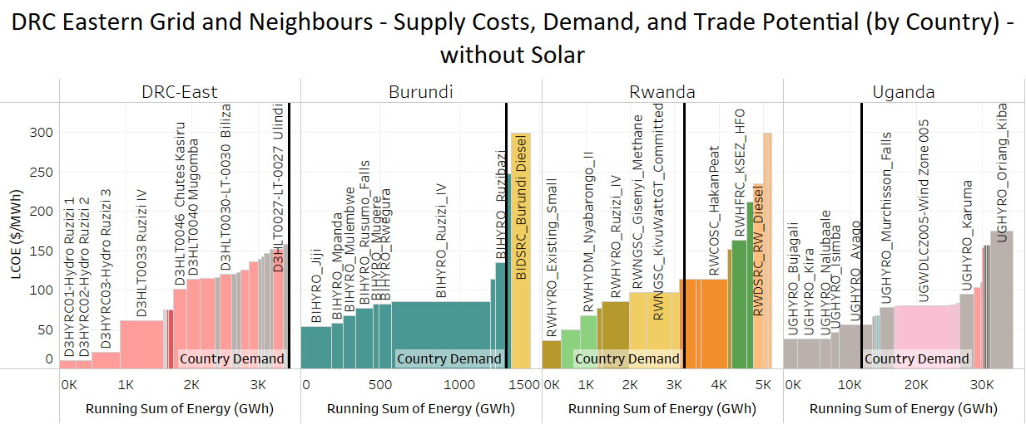

Figure 7 Supply Curve by Country (DRC East+Neighbours) night-time (no solar). Each black horizonal line represents the demand of that specific country. *Note that the axes and scales are not the same for each chart.*

Costs of the last supply option in the curve that meets demand is a bit higher in the East (at ~60$/MWh or ~6 US cents/ kWh) than what was found in the South+West region and neighbouring countries (at ~50 $/MWh or about ~5 US cents/kWh). If this cost difference continues for the long term and significant amounts of cheap solar or geothermal energy are not developed in neighbouring EAPP countries then it may eventually make economic sense to interconnect the Eastern grid to the Southern and Western grids and join SAPP. Note: This is only the bulk generation cost from the power plants, it does not include the costs for transmission and distribution, technical losses/inefficiency, or theft – so this figure cannot be compared directly to the eventual electricity costs paid by any specific consumer which could be significantly higher.

# Conclusions and Future Work

Preliminary analysis shows that if Inga 3 does in-fact materialise by 2030, there would be good opportunity for DRC to export to Angola, Congo, Zambia and to South Africa with the current Grand Inga Treaty. However, should Inga 3 not materialise before Hydro projects in Angola such as Capanda and Lauca, they could provide a lower cost alternative to powering the South+West region.

It shows that in the Eastern parts there is limited trade during the day with all regions able to supply with solar costing more or less the same across the region. However, in combination with developing and refurbishing hydro in the DRC such as the Ruzizi projects, hydro options in Uganda could theoretically provide the Eastern part of the DRC and the region with lower cost power when solar is not available, i.e., during the night.

The analysis conducted above makes several simplifications and to get a better understanding on trade opportunities it would be possible to use an optimization model with explicit detailed representations of countries outside of the DRC. This could be done either by transferring data from the OSeMOSYS 3 region DRC model to the IRENA CMP model or replicating the neighbouring countries from the IRENA CMP model in the OSeMOSYS DRC 3 region model.

The shortcomings that would be addressed, although with perhaps significant effort, include:

* Timing of projects (in terms of the year in which projects become economically viable for the region and/or updates to the realistic times when projects could become operational for the region)
* Time of use considerations: better handling of daily or yearly variability in demand, and RE (solar, wind and hydro) resources variability.
* More explicit costing of trade: for trade to be possible new transmission infrastructure must be built if the current infrastructure is inadequate or non-existent. An optimization model would consider the trade infrastructure costs explicitly, as well as taking energy losses into account when evaluating the feasibility of trade.

Other aspects or topics to consider in more detail include the following:

* Looking beyond the year 2030.
* More detailed representation of trade with South Africa, either directly through HVDC lines or indirectly by South Africa being part of the Southern African Power Pool.
* Investigating scenarios of when internal connection of the major grids within the DRC might become economically viable.

# References

AUDA-NEPAD, 2021, Continental Master Plan (CMP), African Union Development Agency. News report available at: <https://www.nepad.org/news/high-level-eu-and-auda-nepad-officers-report-progress-africas-continental-power-master>

Congo Epela Project, 2022, The Congo Epela Project. Explore data and solutions for energy access in DRC. Resource Matters, University of Cape Town, Reiner Lemoine Institut, and KTH Royal Institute of Technology. Available at: <https://congoepela.resourcematters.org/>

IRENA, 2021, IRENA and IAEA to Help African Union Develop Continental Power Master Plan with EU support. International Renewable Energy Agency. News report available at: <https://irena.org/newsroom/articles/2021/Sep/IRENA-and-IAEA-Selected-to-Help-African-Union-Develop-Continental-Power-Master-Plan-with-EU-support>

IRENA, 2022, System Planning Test (SPLAT) Models for Africa, International Renewable Energy Agency. Available at: <https://irena.org/energytransition/Energy-System-Models-and-Data/System-Planning-Test-Model> and at: <https://irena.org/energytransition/Energy-System-Models-and-Data/Planning-and-Prospects-of-Renewable-Power-in-Africa>

Grand Inga Treaty, 2013, Treaty on the Grand Inga Hydro Power Project between the Republic of South Africa and the Democratic Republic of Congo. Available at: <https://static.pmg.org.za/141104treaty.pdf>

RM and UCT, 2020, Electrifying DR Congo: identifying data-driven solutions – Phase 1 Report. Available at: <https://resourcematters.org/wp-content/uploads/2020/11/Report-Phase-1-Electrifying-DRC.pdf>

UCT, 2022, DRC OSeMOSYS Model Documentation. *Forthcoming.*

# Appendix

## Levelized Cost of Energy (LCOE) Calculation Details

**The Energy that each plant can deliver is calculated as follows:**

Energy (GWh) = Plant Capacity (MW) x Plant Availability (fraction) x 8.76,

Where the plant availability for thermal units is calculated as follows:

Plant Availability (Thermal) = (1 - Planned Outage Rate) x (1 - Forced Outage Rate)

The plant availability for RE plants (wind, solar and hydro) is calculated by taking the average capacity factor over the year.

The LCOE calculation can be simplified in terms of the OSeMOSYS model inputs as follows:

LCOE($/MWh) = (CRF * Investment Cost ($/kW) + Fixed O&M Cost ($/kW)) / (8.76*Availability) + Variable O&M ($/MWh) + Fuel Cost ($/GJ) / Efficiency * 3.6

Where CRF is the Capital Recovery Factor calculated as follows:

(r.(1+r)N-1)/((1+r)N-1), where r is the discount rate and N the life of the plant.

## Abbreviations and coding:

D**1** – Democratic Republic of Congo, **Western Grid** (interconnected to Southern DRC Grid, and connected internationally to the Republic of Congo (Brazzaville) with future potential to connect to Angola)

D**2** – Democratic Republic of Congo, **Southern Grid** (interconnected to Western DRC Grid, and connected internationally to Zambia)

D**3** – Democratic Republic of Congo, **Eastern Grid** (isolated from other DRC grids – interconnected internationally to Rwanda and Burundi with future potential to connect with Uganda)

CD – Democratic Republic of Congo (used instead of D1/2/3 for some technologies)

AO – Angola

CG – Republic of Congo (Brazzaville)

ZM – Zambia

UG – Uganda

RW – Rwanda

BI – Burundi

PP – Power plant

CMP – Continental Master Plan

SAPP – Southern African Power Pool

EAPP – East African Power Pool

CAPP – Central African Power Pool

WAPP – West African Power Pool

AfSEM - African Single Electricity Market

IRENA – International Renewable Energy Agency

Hydro – Hydropower electricity generation plant (with or without dam)

ROR – “Run-of-River” a hydropower plant that does not completely block the flow of the river, and instead diverts part of the flow to the power plant. Usually considered less environmentally disruptive but does not allow storage with a reservoir.

PV – Solar Photovoltaic

HFO – Heavy Fuel Oil (Crude oil derivative – less processed than diesel/gasoline)

CCGT – Combined Cycle Gas Turbine (gas turbines with a heat recovery water heating steam cycle added)

OCGT – Open Cycle Gas Turbine (gas turbines with no heat recovery steam cycle)

MWh – Megawatt Hour (unit of energy, not capacity)

GWh – Gigawatt Hour (1000 Megawatt Hours – unit of energy, not capacity)

LCOE – Levelized Cost of Energy

$/MWh – US Dollars (Levelized Cost of Energy) per Megawatt Hour – average sale price per unit of energy required over the project lifetime to reach payback of the project. (divide by 1000 to get $/kWh)

Solar Thermal – Solar power plant that concentrates the heat from the sun to create steam to drive a turbine and generate electricity, unlike a photovoltaic solar panel which converts sunlight to electricity directly.

Wind – On-shore wind power plants using wind turbines of the appropriate “class” for the wind of the area to be constructed (IEC class I or class II or class III – generally with lower classes (I or II) built with shorter towers in higher windspeed areas and usually cheaper to construct with the opposite true for higher classes)

## Full Supply Curve for the DRC South+West and neighbouring countries

|  |  |  |  |  |
| --- | --- | --- | --- | --- |
| Project/Technology Code and Name | Country and Power Plant Type | Yearly Energy Potential of Project (GWh) | LCOE ($/MWh) Sorted | Running Sum of Energy (GWh) |
| D1HYIC01-Hydro Inga 1 | DRC-S+W Large Hydro PP | 1,845 | 17 | 1,845 |
| D1HYIC02-Hydro Inga 2 | DRC-S+W Large Hydro PP | 7,485 | 17 | 9,329 |
| D1HYSC01-Hydro Sanga | DRC-S+W Large Hydro PP | 63 | 17 | 9,392 |
| D1HYZC01-Hydro Zongo | DRC-S+W Large Hydro PP | 394 | 17 | 9,787 |
| D1HYZC02-Hydro Zongo 2 | DRC-S+W Large Hydro PP | 788 | 17 | 10,575 |
| D2HYKC02-Hydro Nzilo | DRC-S+W Large Hydro PP | 578 | 17 | 11,153 |
| D2HYKC03-Hydro Nseke | DRC-S+W Large Hydro PP | 1,303 | 17 | 12,457 |
| D2HYMC01-Hydro Mwadingusha | DRC-S+W Large Hydro PP | 357 | 17 | 12,814 |
| D1HLT0132-LT-0132 Pioka | DRC-S+W Large Hydro PP | 98 | 19 | 12,912 |
| D1HLT0136-LT-0136 Matadi | DRC-S+W Large Hydro PP | 59 | 24 | 12,971 |
| D1HLT0109 Inga 3 | DRC-S+W Large Hydro PP | 23,326 | 30 | 36,297 |
| AOHYDM_Cacula_Cabasa | AngolaLarge Hydro Dam PP | 18,922 | 38 | 55,219 |
| AOHYDM_Baynes | AngolaLarge Hydro Dam PP | 2,628 | 42 | 57,847 |
| CGHYRO_Gamboma | CongoLarge Hydro ROR PP | 123 | 44 | 57,969 |
| CGHYRO_Mbamba | CongoLarge Hydro ROR PP | 53 | 44 | 58,022 |
| AOHYDM_Lomaum_II | AngolaLarge Hydro Dam PP | 1,402 | 44 | 59,424 |
| AOHYRO_Calengue | AngolaLarge Hydro ROR PP | 2,540 | 49 | 61,964 |
| D2HYKC01-Hydro Koni | DRC-S+W Large Hydro PP | 221 | 50 | 62,185 |
| AOHYDM_Chicapa_Biopio | AngolaLarge Hydro Dam PP | 424 | 52 | 62,609 |
| CGHYDM_Moukoukoulou | CongoLarge Hydro Dam PP | 648 | 52 | 63,258 |
| CGHYRO_N_Komo | CongoLarge Hydro ROR PP | 35 | 52 | 63,293 |
| AOHYDM_Cambambe_I | AngolaLarge Hydro Dam PP | 2,278 | 52 | 65,570 |
| AOHYDM_Capanda | AngolaLarge Hydro Dam PP | 4,555 | 52 | 70,125 |
| AOHYDM_Gove | AngolaLarge Hydro Dam PP | 526 | 52 | 70,651 |
| AOHYDM_Lauca | AngolaLarge Hydro Dam PP | 26,919 | 52 | 97,571 |
| AOHYDM_Lomaum | AngolaLarge Hydro Dam PP | 438 | 52 | 98,009 |
| AOHYDM_Mabubas | AngolaLarge Hydro Dam PP | 224 | 52 | 98,233 |
| AOHYDM_Matala | AngolaLarge Hydro Dam PP | 357 | 52 | 98,590 |
| ZMSOPCZ004-Solar PV Zone 004 | ZambiaSolar PV - Utility PP | 37,327 | 59 | 135,917 |
| ZMSOPCZ003-Solar PV Zone 003 | ZambiaSolar PV - Utility PP | 24,693 | 60 | 160,610 |
| ZMSOPCZ005-Solar PV Zone 005 | ZambiaSolar PV - Utility PP | 99,097 | 60 | 259,707 |
| ZMSOPCZ002-Solar PV Zone 002 | ZambiaSolar PV - Utility PP | 14,097 | 60 | 273,803 |
| D1HLT0183 Kinsuka | DRC-S+W Large Hydro PP | 4,415 | 60 | 278,218 |
| ZMSOPCZ001-Solar PV Zone 001 | ZambiaSolar PV - Utility PP | 59,162 | 60 | 337,380 |
| D1HLT0184 Kibombo Madimba | DRC-S+W Large Hydro PP | 1,177 | 63 | 338,557 |
| AOSOPCZ001-Solar PV Zone 001 | AngolaSolar PV - Utility PP | 97,466 | 63 | 436,024 |
| AOSOPCZ005-Solar PV Zone 005 | AngolaSolar PV - Utility PP | 61,525 | 64 | 497,549 |
| AOSOPCZ002-Solar PV Zone 002 | AngolaSolar PV - Utility PP | 72,300 | 65 | 569,849 |
| AOSOPCZ004-Solar PV Zone 004 | AngolaSolar PV - Utility PP | 161,537 | 65 | 731,386 |
| AOSOPCZ003-Solar PV Zone 003 | AngolaSolar PV - Utility PP | 12,972 | 66 | 744,357 |
| D2SOPC3750-Solar PV | DRC-S+W Solar PV PP | 46 | 67 | 744,403 |
| AOHYDM_Jamba_Ya_Mina | AngolaLarge Hydro Dam PP | 1,577 | 67 | 745,980 |
| ZMWDLCZ003-Wind Zone 003 | ZambiaWind PP | 63,750 | 67 | 809,730 |
| D2HLT0091 Kalengwe | DRC-S+W Large Hydro PP | 1,001 | 67 | 810,731 |
| CDWDLCZ010-Wind Zone 010 | DRC-S+W Wind PP | 1,988 | 67 | 812,719 |
| D2SOPC1343-Solar PV | DRC-S+W Solar PV PP | 1,547 | 68 | 814,267 |
| D2SOPC3580-Solar PV | DRC-S+W Solar PV PP | 45 | 68 | 814,312 |
| D2SOPC1354-Solar PV | DRC-S+W Solar PV PP | 3,963 | 68 | 818,275 |
| D2SOPC3735-Solar PV | DRC-S+W Solar PV PP | 51 | 68 | 818,326 |
| ZMWDLCZ005-Wind Zone 005 | ZambiaWind PP | 15,461 | 69 | 833,787 |
| ZMWDLCZ004-Wind Zone 004 | ZambiaWind PP | 46,611 | 69 | 880,397 |
| D2SOPC1281-Solar PV | DRC-S+W Solar PV PP | 46 | 69 | 880,443 |
| ZMWDLCZ001-Wind Zone 001 | ZambiaWind PP | 14,153 | 69 | 894,596 |
| D2SOPC1333-Solar PV | DRC-S+W Solar PV PP | 51 | 69 | 894,647 |
| D2SOPC1390-Solar PV | DRC-S+W Solar PV PP | 484 | 70 | 895,131 |
| CDWDLCZ002-Wind Zone 002 | DRC-S+W Wind PP | 225 | 70 | 895,355 |
| CDWDLCZ007-Wind Zone 007 | DRC-S+W Wind PP | 419 | 70 | 895,774 |
| D2HLT0139 Mambilima Falls V | DRC-S+W Large Hydro PP | 1,825 | 71 | 897,599 |
| CDWDLCZ006-Wind Zone 006 | DRC-S+W Wind PP | 241 | 72 | 897,841 |
| AOHYRO_Quilengue | AngolaLarge Hydro ROR PP | 4,555 | 72 | 902,396 |
| CDWDLCZ001-Wind Zone 001 | DRC-S+W Wind PP | 616 | 74 | 903,012 |
| D1SOPC1886-Solar PV | DRC-S+W Solar PV PP | 45 | 74 | 903,057 |
| D1SOPC1849-Solar PV | DRC-S+W Solar PV PP | 45 | 74 | 903,102 |
| D1DSBC01-Diesel Bomba | DRC-S+W Diesel PP | 176 | 74 | 903,278 |
| CGBMST_N-KAYI.MILL | CongoBiomass PP | 35 | 75 | 903,313 |
| CGBMST_OUESSO | CongoBiomass PP | 15 | 75 | 903,328 |
| D1SOPC1874-Solar PV | DRC-S+W Solar PV PP | 83 | 75 | 903,410 |
| ZMWDLCZ002-Wind Zone 002 | ZambiaWind PP | 109,420 | 75 | 1,012,831 |
| D1SOPC1807-Solar PV | DRC-S+W Solar PV PP | 66 | 76 | 1,012,897 |
| CDWDLCZ008-Wind Zone 008 | DRC-S+W Wind PP | 1,637 | 76 | 1,014,534 |
| CDWDLCZ005-Wind Zone 005 | DRC-S+W Wind PP | 373 | 76 | 1,014,907 |
| CDWDLCZ004-Wind Zone 004 | DRC-S+W Wind PP | 75 | 77 | 1,014,982 |
| CGSOPCZ002-Solar PV Zone 002 | CongoSolar PV - Utility PP | 22,218 | 77 | 1,037,200 |
| D1HSF1004-SF-1004 SF-1004 | DRC-S+W Large Hydro PP | 849 | 78 | 1,038,048 |
| D1SOPC329-Solar PV | DRC-S+W Solar PV PP | 116 | 78 | 1,038,164 |
| CGSOPCZ001-Solar PV Zone 001 | CongoSolar PV - Utility PP | 27,394 | 78 | 1,065,558 |
| CGSOPCZ005-Solar PV Zone 005 | CongoSolar PV - Utility PP | 30,750 | 79 | 1,096,308 |
| CGSOPCZ003-Solar PV Zone 003 | CongoSolar PV - Utility PP | 7,544 | 79 | 1,103,852 |
| CGSOPCZ004-Solar PV Zone 004 | CongoSolar PV - Utility PP | 1,591 | 79 | 1,105,444 |
| AOWDLCZ005-Wind Zone 005 | AngolaWind PP | 2,791 | 79 | 1,108,235 |
| AOWDLCZ004-Wind Zone 004 | AngolaWind PP | 1,598 | 79 | 1,109,833 |
| D1SOPC1904-Solar PV | DRC-S+W Solar PV PP | 198 | 80 | 1,110,031 |
| D2HLT0141 Kimimbi-Fuka | DRC-S+W Large Hydro PP | 751 | 80 | 1,110,782 |
| CDWDLCZ009-Wind Zone 009 | DRC-S+W Wind PP | 87 | 81 | 1,110,868 |
| AONGCC_Angola_CCGT_NG | AngolaNatural Gas PP | 931 | 81 | 1,111,799 |
| CGHYRO_Mourala | CongoLarge Hydro ROR PP | 374 | 81 | 1,112,173 |
| D2HLT0075 Nzilo II | DRC-S+W Large Hydro PP | 589 | 83 | 1,112,762 |
| D1HSF0873-SF-0873 SF-0873 | DRC-S+W Large Hydro PP | 551 | 83 | 1,113,313 |
| CDWDLCZ003-Wind Zone 003 | DRC-S+W Wind PP | 223 | 83 | 1,113,536 |
| D1SOPC1835-Solar PV | DRC-S+W Solar PV PP | 263 | 83 | 1,113,799 |
| ZMHYDM_Kafue_Gorge | ZambiaLarge Hydro Dam PP | 5,784 | 84 | 1,119,583 |
| AONGCC_P_Angola_Soyo | AngolaNatural Gas PP | 5,585 | 84 | 1,125,168 |
| AOWDLCZ002-Wind Zone 002 | AngolaWind PP | 2,581 | 84 | 1,127,749 |
| ZMHYDM_Kafue_Gorge_Lower | ZambiaLarge Hydro Dam PP | 4,348 | 85 | 1,132,097 |
| D2HLT0094 Mumbotuta M | DRC-S+W Large Hydro PP | 1,030 | 87 | 1,133,128 |
| D2HLT0140 Mumbotuta CX | DRC-S+W Large Hydro PP | 1,472 | 87 | 1,134,599 |
| D2HLT0138 Mambilima Falls I | DRC-S+W Large Hydro PP | 1,472 | 88 | 1,136,071 |
| CGWDLCZ001-Wind Zone 001 | CongoWind PP | 64 | 91 | 1,136,135 |
| D1HSF0980-SF-0980 SF-0980 | DRC-S+W Large Hydro PP | 596 | 91 | 1,136,730 |
| D1HSF1011-SF-1011 SF-1011 | DRC-S+W Large Hydro PP | 880 | 91 | 1,137,610 |
| AOWDLCZ003-Wind Zone 003 | AngolaWind PP | 23,336 | 92 | 1,160,946 |
| CGHYRO_Kouembali | CongoLarge Hydro ROR PP | 623 | 92 | 1,161,569 |
| CGHYRO_Imboulou | CongoLarge Hydro ROR PP | 496 | 92 | 1,162,065 |
| D2HLT0084 Mambilima Falls II | DRC-S+W Large Hydro PP | 618 | 95 | 1,162,683 |
| AOWDLCZ001-Wind Zone 001 | AngolaWind PP | 147,161 | 95 | 1,309,843 |
| D1SOPC296-Solar PV | DRC-S+W Solar PV PP | 680 | 97 | 1,310,524 |
| D1HSF0997-SF-0997 SF-0997 | DRC-S+W Large Hydro PP | 325 | 97 | 1,310,849 |
| CGHYRO_Liouessa | CongoLarge Hydro ROR PP | 75 | 99 | 1,310,924 |
| ZMHYDM_Kariba_NBE | ZambiaLarge Hydro Dam PP | 5,288 | 100 | 1,316,212 |
| AOHYDM_Jamba_Ya_Oma | AngolaLarge Hydro Dam PP | 657 | 108 | 1,316,869 |
| CGHYRO_Sounda_Gorge | CongoLarge Hydro ROR PP | 1,367 | 112 | 1,318,236 |
| D2HSF0852-Solar PV | DRC-S+W Large Hydro PP | 217 | 114 | 1,318,453 |
| ZMCOSC01-Maamba Coal I (St) | ZambiaCoal PP | 2,234 | 114 | 1,320,687 |
| ZMCOSC10_Maamba Coal II | ZambiaCoal PP | 4,468 | 114 | 1,325,155 |
| ZMCOSC30-Zambia_Coal | ZambiaCoal PP | 1,973 | 114 | 1,327,128 |
| D1HSF0698-SF-0698 SF-0698 | DRC-S+W Large Hydro PP | 164 | 115 | 1,327,292 |
| CGNGSC_DJENO.TOTAL | CongoNatural Gas PP | 82 | 115 | 1,327,374 |
| AOHYRO_Camambe_II | AngolaLarge Hydro ROR PP | 2,782 | 115 | 1,330,156 |
| AONGSC_E_CIF | AngolaNatural Gas PP | 894 | 116 | 1,331,050 |
| CGNGSC_COTE.MATEVE | CongoNatural Gas PP | 2,234 | 116 | 1,333,284 |
| CGNGSC_DJENO.ENI | CongoNatural Gas PP | 186 | 116 | 1,333,470 |
| AONGSC_Angola_OCGT_NG | AngolaNatural Gas PP | 15,638 | 116 | 1,349,108 |
| D1HSF1005-SF-1005 SF-1005 | DRC-S+W Large Hydro PP | 565 | 117 | 1,349,673 |
| D2HLT0182 Kambuji | DRC-S+W Large Hydro PP | 166 | 117 | 1,349,839 |
| D1HSF0994-SF-0994 SF-0994 | DRC-S+W Large Hydro PP | 339 | 117 | 1,350,179 |
| AOHYRO_Cafula | AngolaLarge Hydro ROR PP | 1,415 | 121 | 1,351,593 |
| D2HSF0910-Solar PV | DRC-S+W Large Hydro PP | 202 | 123 | 1,351,795 |
| D1HSF0670-SF-0670 SF-0670 | DRC-S+W Large Hydro PP | 134 | 125 | 1,351,929 |
| AOHYRO_Tumuludo | AngolaLarge Hydro ROR PP | 1,296 | 127 | 1,353,225 |
| CGHYRO_Djoue | CongoLarge Hydro ROR PP | 53 | 130 | 1,353,278 |
| ZMHYDM_Ithezi_Thezi | ZambiaLarge Hydro Dam PP | 446 | 132 | 1,353,724 |
| D1SOTS00-Generic Solar thermal with Storage | DRC-S+W Solar PV PP | 618 | 135 | 1,354,342 |
| D2SOTS00-Generic Solar thermal with Storage | DRC-S+W Solar PV PP | 618 | 135 | 1,354,960 |
| D1SOTN00-Generic Solar thermal no storage | DRC-S+W Solar PV PP | 429 | 137 | 1,355,390 |
| D2SOTN00-Generic Solar thermal no storage | DRC-S+W Solar PV PP | 429 | 137 | 1,355,819 |
| D1HSF0996-SF-0996 SF-0996 | DRC-S+W Large Hydro PP | 251 | 137 | 1,356,070 |
| D1HSF0937-SF-0937 SF-0937 | DRC-S+W Large Hydro PP | 121 | 138 | 1,356,191 |
| CGHYRO_Chollet | CongoLarge Hydro ROR PP | 823 | 139 | 1,357,014 |
| AOHYRO_Zenzo_I | AngolaLarge Hydro ROR PP | 1,296 | 142 | 1,358,310 |
| D1HLT0089-LT-0089 Kilemfu | DRC-S+W Large Hydro PP | 147 | 142 | 1,358,457 |
| D1HSF0889-SF-0889 SF-0889 | DRC-S+W Large Hydro PP | 169 | 143 | 1,358,626 |
| D1HLT0106-LT-0106 Bamba | DRC-S+W Large Hydro PP | 108 | 144 | 1,358,734 |
| D2HLT0180 Dikolongo aval | DRC-S+W Small Hydro PP | 86 | 145 | 1,358,821 |
| D1HLT0127-LT-0127 Ruki | DRC-S+W Large Hydro PP | 559 | 145 | 1,359,380 |
| D2HLT0181 Chutes de Kawa | DRC-S+W Small Hydro PP | 88 | 146 | 1,359,468 |
| D1HSF0885-SF-0885 SF-0885 | DRC-S+W Large Hydro PP | 144 | 149 | 1,359,612 |
| D1HSF0897-SF-0897 SF-0897 | DRC-S+W Large Hydro PP | 142 | 151 | 1,359,754 |
| D1HSF0741-SF-0741 SF-0741 | DRC-S+W Small Hydro PP | 75 | 153 | 1,359,829 |
| D2HLT0166 Kayo | DRC-S+W Large Hydro PP | 167 | 154 | 1,359,996 |
| D1HLT0087-LT-0087 Banda | DRC-S+W Large Hydro PP | 177 | 155 | 1,360,172 |
| D1HSF0987-SF-0987 SF-0987 | DRC-S+W Large Hydro PP | 187 | 155 | 1,360,360 |
| D1HSF0705-SF-0705 SF-0705 | DRC-S+W Small Hydro PP | 62 | 156 | 1,360,422 |
| D2HLT0165 Kabundji | DRC-S+W Large Hydro PP | 172 | 156 | 1,360,594 |
| D1HSF0988-SF-0988 SF-0988 | DRC-S+W Large Hydro PP | 190 | 157 | 1,360,783 |
| D2HLT0171 Mukuleshi | DRC-S+W Large Hydro PP | 172 | 157 | 1,360,955 |
| D1HLT0113-LT-0113 Ingende | DRC-S+W Large Hydro PP | 397 | 157 | 1,361,353 |
| D1HSF0878-SF-0878 SF-0878 | DRC-S+W Small Hydro PP | 49 | 161 | 1,361,402 |
| D2HSF0969-Solar PV | DRC-S+W Large Hydro PP | 183 | 162 | 1,361,585 |
| D1HLT0107 Dibaya-Lubwe | DRC-S+W Large Hydro PP | 177 | 163 | 1,361,761 |
| D1HSF0844-SF-0844 SF-0844 | DRC-S+W Large Hydro PP | 102 | 165 | 1,361,863 |
| D2HSF0893-Solar PV | DRC-S+W Small Hydro PP | 56 | 166 | 1,361,920 |
| D2HSF0779-Solar PV | DRC-S+W Small Hydro PP | 46 | 168 | 1,361,966 |
| D1HSF0689-SF-0689 SF-0689 | DRC-S+W Small Hydro PP | 65 | 169 | 1,362,030 |
| D2HSF0915-Solar PV | DRC-S+W Small Hydro PP | 65 | 169 | 1,362,096 |
| D1HLT0185-LT-0185 Kwilu | DRC-S+W Small Hydro PP | 88 | 170 | 1,362,184 |
| AOHFRC_E_Benguela_(Eng) | AngolaHFO PP | 140 | 171 | 1,362,324 |
| CGHFRC_POINTE-NOIRE | CongoHFO PP | 93 | 171 | 1,362,417 |
| ZMHYDM_Lusiwasi | ZambiaLarge Hydro Dam PP | 138 | 186 | 1,362,554 |
| ZMHYRO_Musonda_Falls | ZambiaLarge Hydro ROR PP | 247 | 193 | 1,362,801 |
| ZMHFRC10-Zambia_Indola Energy (HFO) | ZambiaHFO PP | 147 | 194 | 1,362,949 |
| ZMHYRO_Lusiwasi_Extension | ZambiaLarge Hydro ROR PP | 212 | 194 | 1,363,160 |
| ZMHYRO_Lusiwasi_Lower | ZambiaLarge Hydro ROR PP | 217 | 194 | 1,363,377 |
| ZMHYRO_Chishimba_Falls_Lunzua | ZambiaLarge Hydro ROR PP | 84 | 201 | 1,363,461 |
| ZMHYRO_Kabompo_Gorge | ZambiaLarge Hydro ROR PP | 225 | 202 | 1,363,686 |
| ZMHYRO_Victoria_Falls | ZambiaLarge Hydro ROR PP | 243 | 217 | 1,363,928 |
| ZMHYRO_Batoka_Gorge_North | ZambiaLarge Hydro ROR PP | 2,695 | 218 | 1,366,623 |
| ZMHYRO_Mkushi | ZambiaLarge Hydro ROR PP | 152 | 218 | 1,366,775 |
| ZMHYRO_Devils_Gorge_N | ZambiaLarge Hydro ROR PP | 1,353 | 226 | 1,368,128 |
| ZMHYRO_Kalungwishi_I | ZambiaLarge Hydro ROR PP | 218 | 227 | 1,368,346 |
| ZMHYRO_Mambilima_Falls_I-II | ZambiaLarge Hydro ROR PP | 704 | 236 | 1,369,050 |
| CGDSRC_POINTE-NOIRE.SNE | CongoDiesel PP | 61 | 236 | 1,369,111 |
| CGDSRC_POINTE-NOIRE | CongoDiesel PP | 31 | 237 | 1,369,142 |
| AODSRC_E_Cazenga | AngolaDiesel PP | 2,643 | 237 | 1,371,785 |
| AODSRC_E_Boavista | AngolaDiesel PP | 4,331 | 238 | 1,376,116 |
| AODSRC_E_Quileva | AngolaDiesel PP | 1,582 | 238 | 1,377,699 |
| CGDSRC_MPILA | CongoDiesel PP | 224 | 238 | 1,377,923 |
| D1NGSO00-Solar thermal with Gas | DRC-S+W Gas PP | 429 | 300 | 1,378,352 |
| D2NGSO00 Solar thermal with Gas | DRC-S+W Gas PP | 429 | 300 | 1,378,781 |
| ZMHYRO_Lunsemfwa_Kalungwishi_II | ZambiaLarge Hydro ROR PP | 119 | 354 | 1,378,900 |

## Full Supply Curve for the DRC Eastern Region and Neighbouring Countries

|  |  |  |  |  |
| --- | --- | --- | --- | --- |
| Project/Technology Code and Name | Country and Power Plant Type | Yearly Energy Potential of Project (GWh) | LCOE ($/MWh) Sorted | Running Sum of Energy (GWh) |
| D3HYRC01-Hydro Ruzizi 1 | DRC-EastLarge Hydro ROR PP | 245 | 10 | 245 |
| D3HYRC02-Hydro Ruzizi 2 | DRC-EastLarge Hydro ROR PP | 247 | 10 | 492 |
| D3HYRC03-Hydro Ruzizi 3 | DRC-EastLarge Hydro ROR PP | 425 | 21 | 917 |
| RWHYRO_Existing_Small | RwandaLarge Hydro ROR PP | 429 | 36 | 1,346 |
| UGHYRO_Bujagali | UgandaLarge Hydro ROR PP | 2,190 | 38 | 3,536 |
| UGHYRO_Kira | UgandaLarge Hydro ROR PP | 3,329 | 38 | 6,865 |
| UGHYRO_Nalubaale | UgandaLarge Hydro ROR PP | 1,577 | 38 | 8,442 |
| UGHYRO_Isimba | UgandaLarge Hydro ROR PP | 1,318 | 46 | 9,760 |
| RWHYDM_Rwanda_Ruzizi_III | RwandaLarge Hydro Dam PP | 438 | 50 | 10,198 |
| BIHYRO_Jiji | BurundiLarge Hydro ROR PP | 192 | 54 | 10,391 |
| UGHYRO_Ayago | UgandaLarge Hydro ROR PP | 5,032 | 56 | 15,422 |
| BIHYRO_Mpanda | BurundiLarge Hydro ROR PP | 73 | 58 | 15,495 |
| UGSOPCZK23-PV Zone K | UgandaSolar PV - Utility PP | 400 | 60 | 15,896 |
| D3HLT0033 Ruzizi IV | DRC-EastLarge Hydro ROR PP | 655 | 61 | 16,550 |
| UGSOPCZ004-Solar PV Zone 004 | UgandaSolar PV - Utility PP | 11,604 | 61 | 28,155 |
| UGSOPCZ003-Solar PV Zone 003 | UgandaSolar PV - Utility PP | 7,530 | 61 | 35,685 |
| BISOPCZ004-Solar PV Zone 004 | BurundiSolar PV - Utility PP | 1,320 | 63 | 37,005 |
| UGSOPCZ005-Solar PV Zone 005 | UgandaSolar PV - Utility PP | 15,350 | 63 | 52,355 |
| UGSOPCZ001-Solar PV Zone 001 | UgandaSolar PV - Utility PP | 23,121 | 63 | 75,476 |
| UGSOPCZ002-Solar PV Zone 002 | UgandaSolar PV - Utility PP | 18,331 | 63 | 93,806 |
| UGHYRO_Existing_Small | UgandaLarge Hydro ROR PP | 306 | 66 | 94,112 |
| RWSOPCZ002-Solar PV Zone 002 | RwandaSolar PV - Utility PP | 1,268 | 66 | 95,380 |
| RWSOPCZ005-Solar PV Zone 005 | RwandaSolar PV - Utility PP | 76 | 66 | 95,456 |
| RWHYDM_Nyabarongo_II | RwandaLarge Hydro Dam PP | 381 | 67 | 95,837 |
| BIHYRO_Mulembwe | BurundiLarge Hydro ROR PP | 79 | 67 | 95,917 |
| UGBMST01-Existing Kakira | UgandaBiomass PP | 299 | 67 | 96,216 |
| UGBMST02-Existing Kinyara | UgandaBiomass PP | 205 | 67 | 96,421 |
| UGBMST10-Committed Kinyara2 | UgandaBiomass PP | 246 | 67 | 96,668 |
| BISOPCZ002-Solar PV Zone 002 | BurundiSolar PV - Utility PP | 1,751 | 68 | 98,419 |
| UGWDLCZ003-Wind Zone 003 | UgandaWind PP | 81 | 69 | 98,500 |
| RWSOPCZ004-Solar PV Zone 004 | RwandaSolar PV - Utility PP | 2,495 | 70 | 100,995 |
| BISOPCZ001-Solar PV Zone 001 | BurundiSolar PV - Utility PP | 1,676 | 70 | 102,672 |
| RWSOPCZ001-Solar PV Zone 001 | RwandaSolar PV - Utility PP | 2,375 | 70 | 105,046 |
| RWSOPCZ003-Solar PV Zone 003 | RwandaSolar PV - Utility PP | 626 | 70 | 105,672 |
| BISOPCZ005-Solar PV Zone 005 | BurundiSolar PV - Utility PP | 775 | 71 | 106,448 |
| D3SOPC330-Solar PV | DRC-EastSolar PV - Utility PP | 592 | 72 | 107,039 |
| D3SOPC1616-Solar PV | DRC-EastSolar PV - Utility PP | 69 | 73 | 107,108 |
| D3SOPC331-Solar PV | DRC-EastSolar PV - Utility PP | 1,690 | 73 | 108,798 |
| D3DSBC02-Diesel Bandundu | DRC-EastDiesel PP | 12 | 74 | 108,811 |
| D3DSBC03-Diesel Basankusu | DRC-EastDiesel PP | 5 | 74 | 108,816 |
| D3DSBC04-Diesel Boende | DRC-EastDiesel PP | 6 | 74 | 108,822 |
| D3DSBC05-Diesel Bumba | DRC-EastDiesel PP | 3 | 74 | 108,825 |
| D3DSBC06-Diesel Buta | DRC-EastDiesel PP | 14 | 74 | 108,839 |
| D3DSBC07-Diesel Butembo | DRC-EastDiesel PP | 2 | 74 | 108,841 |
| D3DSGC01-Diesel Gemena | DRC-EastDiesel PP | 37 | 74 | 108,879 |
| D3DSGC02-Diesel Goma | DRC-EastDiesel PP | 75 | 74 | 108,954 |
| BISOPCZ003-Solar PV Zone 003 | BurundiSolar PV - Utility PP | 250 | 76 | 109,203 |
| BIHYRO_Rusumo_Falls | BurundiLarge Hydro ROR PP | 110 | 77 | 109,313 |
| RWHYRO_Rusumo | RwandaLarge Hydro ROR PP | 110 | 77 | 109,423 |
| UGHYRO_Murchisson_Falls | UgandaLarge Hydro ROR PP | 2,050 | 78 | 111,473 |
| UGWDLCZ004-Wind Zone 004 | UgandaWind PP | 501 | 79 | 111,973 |
| UGWDLCZ005-Wind Zone 005 | UgandaWind PP | 7,962 | 81 | 119,936 |
| UGWDLCZ002-Wind Zone 002 | UgandaWind PP | 1,024 | 82 | 120,960 |
| BIHYRO_Mugere | BurundiLarge Hydro ROR PP | 35 | 82 | 120,995 |
| BIHYRO_Rwegura | BurundiLarge Hydro ROR PP | 79 | 82 | 121,073 |
| UGWDLCZ001-Wind Zone 001 | UgandaWind PP | 417 | 84 | 121,491 |
| BIHYRO_Ruzizi_IV | BurundiLarge Hydro ROR PP | 622 | 85 | 122,113 |
| RWHYRO_Ruzizi_IV | RwandaLarge Hydro ROR PP | 622 | 85 | 122,735 |
| UGHYRO_Karuma | UgandaLarge Hydro ROR PP | 2,108 | 94 | 124,843 |
| RWNGSC_Gisenyi_Methane | RwandaNatural Gas PP | 372 | 97 | 125,215 |
| RWNGSC_KivuWattGT_Committed | RwandaNatural Gas PP | 559 | 97 | 125,774 |
| RWNGSC_KivuWattGT_Existing | RwandaNatural Gas PP | 186 | 97 | 125,960 |
| RWNGSC_KP1_Gisenyi_Methane | RwandaNatural Gas PP | 13 | 97 | 125,973 |
| D3HLT0046 Chutes Kasiru | DRC-EastLarge Hydro ROR PP | 196 | 101 | 126,169 |
| D3HLT0040 Mugomba | DRC-EastLarge Hydro ROR PP | 196 | 114 | 126,366 |
| BIHYRO_Kagunizi | BurundiLarge Hydro ROR PP | 36 | 114 | 126,402 |
| RWCOSC_Akanyaru_Peat | RwandaCoal PP | 372 | 114 | 126,774 |
| RWCOSC_Gishoma_Peat | RwandaCoal PP | 112 | 114 | 126,886 |
| RWCOSC_HakanPeat | RwandaCoal PP | 596 | 114 | 127,481 |
| D3HSF0982-SF-0982 SF-0982 | DRC-EastLarge Hydro ROR PP | 231 | 114 | 127,712 |
| D3HSF0931-SF-0931 SF-0931 | DRC-EastSmall Hydro PP | 82 | 116 | 127,795 |
| D3HLT0030-LT-0030 Biliza | DRC-EastLarge Hydro ROR PP | 167 | 120 | 127,962 |
| D3HSF0759-SF-0759 SF-0759 | DRC-EastSmall Hydro PP | 73 | 120 | 128,035 |
| D3HLT0031-LT-0031 Kiliba - Katobo | DRC-EastSmall Hydro PP | 74 | 122 | 128,108 |
| D3HLT0067 Muhuma | DRC-EastLarge Hydro ROR PP | 123 | 125 | 128,231 |
| BIHYRO_Ruzibazi | BurundiLarge Hydro ROR PP | 67 | 134 | 128,298 |
| D3SOTS00-Solar thermal with Storage | DRC-EastSolar PV - Utility PP | 618 | 135 | 128,916 |
| D3HSF0911-SF-0911 SF-0911 | DRC-EastLarge Hydro ROR PP | 140 | 136 | 129,056 |
| D3SOTN00-Solar thermal no storage | DRC-EastSolar PV - Utility PP | 429 | 137 | 129,485 |
| D3HSF0421-SF-0421 SF-0421 | DRC-EastSmall Hydro PP | 49 | 139 | 129,534 |
| D3HSF0540-SF-0540 SF-0540 | DRC-EastSmall Hydro PP | 35 | 142 | 129,570 |
| D3HSF0939-SF-0939 SF-0939 | DRC-EastSmall Hydro PP | 87 | 147 | 129,657 |
| RWHYRO_Nyabarongo_I | RwandaLarge Hydro ROR PP | 94 | 151 | 129,751 |
| D3HSF0763-SF-0763 SF-0763 | DRC-EastSmall Hydro PP | 52 | 151 | 129,802 |
| D3HLT0027-LT-0027 Ulindi | DRC-EastLarge Hydro ROR PP | 147 | 152 | 129,949 |
| UGCOSC10-Committed Kabale_Peat | UgandaCoal PP | 246 | 153 | 130,195 |
| UGHFRC01-Existing Electromaxx | UgandaHFO PP | 350 | 157 | 130,545 |
| UGHFRC02-Existing Namanve | UgandaHFO PP | 350 | 157 | 130,896 |
| UGHFRC10-Committed Albatros | UgandaHFO PP | 350 | 157 | 131,246 |
| D3HSF0856-SF-0856 SF-0856 | DRC-EastSmall Hydro PP | 94 | 158 | 131,340 |
| CDWDLCZ001-Wind Zone 011 | DRC-EastWind PP | 35 | 162 | 131,375 |
| RWHFRC_KSEZ_HFO | RwandaHFO PP | 350 | 163 | 131,725 |
| UGHYRO_Oriang_Kiba | UgandaLarge Hydro ROR PP | 3,349 | 174 | 135,074 |
| RWHFRC_Jabana2 | RwandaHFO PP | 140 | 211 | 135,214 |
| CDWDLCZ002-Wind Zone 012 | DRC-EastWind PP | 25 | 216 | 135,239 |
| RWDSRC_RW_Diesel | RwandaDiesel PP | 230 | 235 | 135,469 |
| CDWDLCZ003-Wind Zone 013 | DRC-EastWind PP | 27 | 242 | 135,496 |
| BIHYRO_Kabu | BurundiLarge Hydro ROR PP | 32 | 248 | 135,528 |
| BIDSRC_Burundi Diesel | BurundiDiesel PP | 119 | 299 | 135,647 |
| RWDSRC_Gikondo | RwandaDiesel PP | 70 | 299 | 135,717 |
| RWDSRC_Jabana1 | RwandaDiesel PP | 50 | 299 | 135,768 |
| RWDSRC_Mukungwa | RwandaDiesel PP | 70 | 299 | 135,838 |
| D3NGSO00-Solar thermal with Gas | DRC-EastNatural Gas PP | 429 | 300 | 136,267 |